ABSTRACT:

A core feature of e-prescribing is the electronic exchange of prescription data between physician practices and pharmacies, which can potentially improve the efficiency of the prescribing process and reduce medication errors in simple word e-prescription can be defined as Electronic prescribing or e-prescribing is the electronic transmission of prescription information from the prescriber’s computer to a pharmacy computer

Benefits:

* Improved patient quality of care by decreasing risk of medication errors and to prescribe to pharmacy electronically
* Warning and alert systems at point of prescribing
* Reduces or eliminates phone calls and call-backs to pharmacies.
* Reduces faxes to pharmacies – Save Paper
* Improved reporting by querying the system for the frequency of medication prescribed.

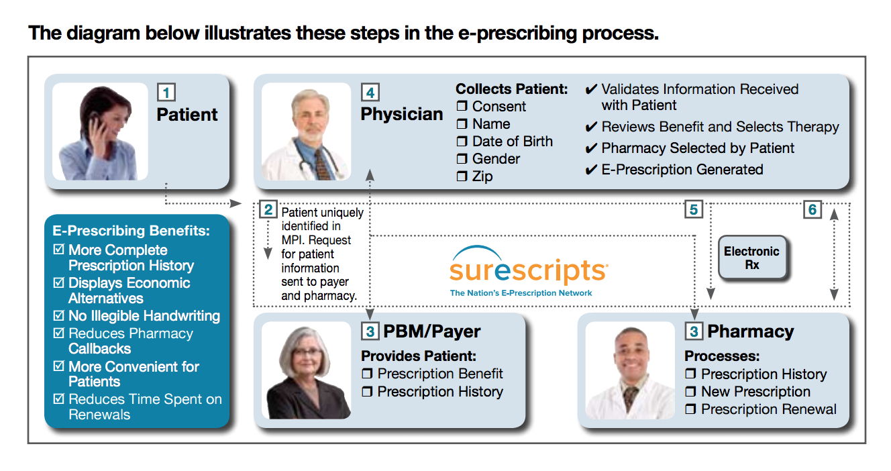

E-Prescribing Adoption and Implementation Challenges

At the end of 2020, over 460,000 prescribers or about one-third of all office-based prescribers were actively prescribing.

Key Takeaways: •

* The Health Information Technology for Economic and Clinical Health Act (HITECH) makes incentive payments available to assist hospitals and individual physicians in adopting electronic health record (EHR) technologies
* To receive incentive payments, physicians must prove that they meet government requirements for meaningful use of EHR technology which will evolve over 3 “Stages” from 2011 through 2015.
* E-Prescribing is a key component of meaningful use. Most notably, Stage 1 of meaningful use requires that at least 40 percent of eligible prescriptions are prepared and sent to pharmacies electronically
* Future stages of meaningful use place increasing importance on the send and receipt of clinical information between health care providers to inform patient care.
* This includes the receipt and use of patient formulary and eligibility information from payers — accessed through use of e-prescribing technology certified for this communication.
* It also includes increasing requirements for the percentage of eligible prescriptions prepared and sent to pharmacies electronically.

How Does E-Prescribing Fit with Meaningful Use?

E-prescribing is one of the more mature and successful components of the meaningful use criteria established by CMS. The following aspects of Stage 1 meaningful use are supported by e-prescribing: • 40 percent of prescriptions must be transmitted electronically • Drug-drug and drug-allergy interaction checking must be performed • Active medication lists must be maintained • Allergy list must be maintained • Medication reconciliation must be performed • Information must be exchanged electronically • Formulary checking (menu option in Stage 1, expected to be required in Stage 2)

Growth of e-Prescription :

